EWMA correlation: USDCHF and EURGBP
Method 06 / daily log returns / lambda = 0.94 / Alpari D1 full available history

Study setup
Logical pair: USDCHF , EURGBP
Broker symbols: USDCHF_i , EURGBP_i
Snapshot: 2026-11-03_majors_alpari_D1
Timeframe: D1
Matched return window: 1999-01-06 to 2026-11-02 (UTC bar dates)
Matched return count n: 7182
Dropped unfinished last bar dated 2026-11-03 UTC after a tick-volume check against the prior complete day.
Lambda: 0.94 (today weight 0.06)
Burn-in ignored in path summaries and chart: first 60 updates
Mean adjustment: each leg demeaned by its mean on the matched rows
Seeds: c_0 = v_x,0 = v_y,0 = 0
Complete matched rows (Excel): USDCHF-EURGBP_EWMA_D1.xlsx
Complete matched rows (HTML table): USDCHF-EURGBP_EWMA_D1_data.html

Method carried forward
EWMA correlation updates covariance and variances of mean-adjusted daily log returns of close, ln(close_t / close_t-1), with lambda = 0.94 (6% weight on today's product or square, 94% on yesterday's EWMA state). Quotes are not inverted. Each leg is demeaned by its mean on the matched rows; that mean uses the full sample, so the rho path is a full-sample description, not a live filter. Seeds start at zero. Path summaries and the chart ignore the first 60 updates so the zero seed has faded. The headline is rho on the last day. rho is symmetric under swap of the two symbols. A high |rho| does not prove cause, lead-lag, or a trading signal. Today's return sits inside today's rho, so the estimate can only inform a later decision. Same-sample Pearson r is a side check only.

Results
Latest EWMA rho: 0.092712
Post-burn-in path (n=7122): mean=-0.322479, median=-0.349901, min=-0.891722, max=0.518322, std=0.269872
Share of post-burn-in days with |rho| >= 0.4: 43.51%; |rho| >= 0.7: 5.77%
Same-sample Pearson r: -0.325886
Latest rho minus r: 0.418599

Conclusion
Over 7182 matched daily log-return rows for USDCHF and EURGBP (broker quote directions unchanged), latest EWMA rho with lambda=0.94 is 0.0927 (positive, weak recent linear link in this sample). After a 60-day burn-in, path mean is -0.3225, std is 0.2699, and the range is [-0.8917, 0.5183]. Same-sample Pearson r is -0.3259 (latest rho minus r = 0.4186). This does not establish cause, lead-lag, or a lasting trading rule.

Charts
Daily closes

Daily log returns
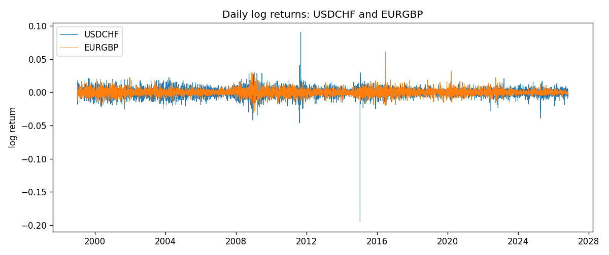
EWMA rho path with Pearson r reference
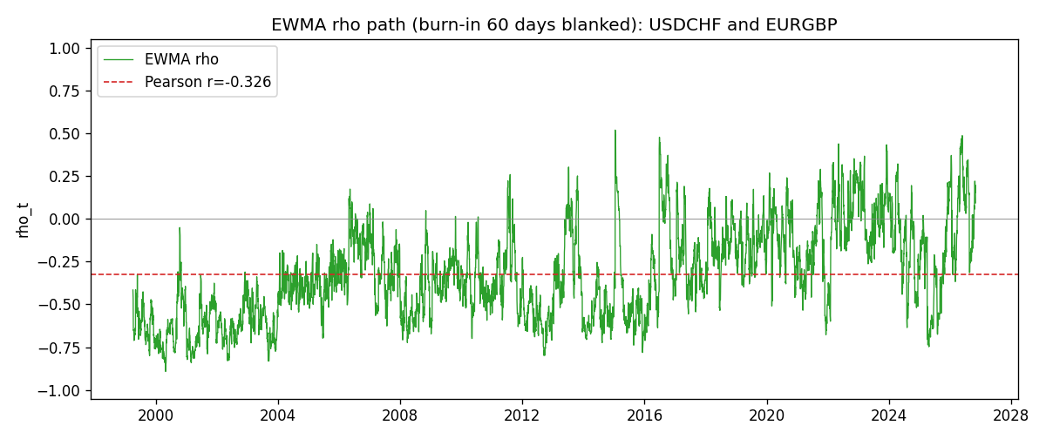

Data report
Every matched row that entered the EWMA recursion is stored in the sibling Excel workbook named USDCHF-EURGBP_EWMA_D1.xlsx. That file is the complete data archive for redrawing charts. Embedding all rows as a Word table is impractical at this length; the Word file holds the column list, column summaries, and the first and last 15 matched rows.
Columns: time, USDCHF_open, EURGBP_open, USDCHF_high, EURGBP_high, USDCHF_low, EURGBP_low, USDCHF_close, EURGBP_close, USDCHF_tick_volume, EURGBP_tick_volume, USDCHF_spread, EURGBP_spread, USDCHF_real_volume, EURGBP_real_volume, USDCHF_log_return, EURGBP_log_return, USDCHF_x_demeaned, EURGBP_y_demeaned, c_t, v_x, v_y, rho_t
Column summaries (matched calculation rows)
column | count | mean | std | min | 25% | 50% | 75% | max
USDCHF_open | 7182 | 1.0972493 | 0.25210985 | 0.72022 | 0.9204925 | 0.989875 | 1.237175 | 1.8219
EURGBP_open | 7182 | 0.7869939 | 0.09664695 | 0.5734 | 0.6877 | 0.833905 | 0.865225 | 0.9769
USDCHF_high | 7182 | 1.1025378 | 0.25385182 | 0.73305 | 0.924695 | 0.99351 | 1.242175 | 1.8313
EURGBP_high | 7182 | 0.79007306 | 0.09702085 | 0.5789 | 0.6897 | 0.836955 | 0.8681 | 0.9799
USDCHF_low | 7182 | 1.092133 | 0.25052689 | 0.08565 | 0.9171825 | 0.986205 | 1.2312 | 1.8121
EURGBP_low | 7182 | 0.7842938 | 0.09646529 | 0.5682 | 0.685725 | 0.83166 | 0.86287 | 0.9661
USDCHF_close | 7182 | 1.09724 | 0.25200902 | 0.72025 | 0.9207375 | 0.98991 | 1.23715 | 1.8217
EURGBP_close | 7182 | 0.78703952 | 0.09664503 | 0.5735 | 0.687825 | 0.83398 | 0.865375 | 0.977
USDCHF_tick_volume | 7182 | 74362.695 | 113509.88 | 18 | 12814.25 | 40258.5 | 70446 | 858589
EURGBP_tick_volume | 7182 | 87145.49 | 145506.26 | 154 | 6593.75 | 44371 | 81432 | 1424684
USDCHF_spread | 7182 | 26.020746 | 24.692144 | 0 | 5 | 16 | 50 | 100
EURGBP_spread | 7182 | 21.320663 | 19.117614 | 0 | 4 | 13 | 40 | 50
USDCHF_real_volume | 7182 | 2.3303821e+10 | 8.915094e+10 | 0 | 0 | 0 | 0 | 1.9331921e+12
EURGBP_real_volume | 7182 | 2.7876168e+10 | 1.3522356e+11 | 0 | 0 | 0 | 0 | 3.5726265e+12
USDCHF_log_return | 7182 | -7.199e-05 | 0.00659004 | -0.19545699 | -0.00335239 | 7.626e-05 | 0.00331734 | 0.09051364
EURGBP_log_return | 7182 | 2.529e-05 | 0.00487429 | -0.03067367 | -0.00262165 | -0.00010006 | 0.00256425 | 0.06075387
USDCHF_x_demeaned | 7182 | -0 | 0.00659004 | -0.195385 | -0.0032804 | 0.00014825 | 0.00338934 | 0.09058563
EURGBP_y_demeaned | 7182 | 0 | 0.00487429 | -0.03069896 | -0.00264694 | -0.00012535 | 0.00253896 | 0.06072858
c_t | 7182 | -1.047e-05 | 1.369e-05 | -0.00014812 | -1.614e-05 | -7.53e-06 | -1.98e-06 | 0.00011381
v_x | 7182 | 4.339e-05 | 9.023e-05 | 4.48e-06 | 1.836e-05 | 2.968e-05 | 4.743e-05 | 0.00231221
v_y | 7182 | 2.375e-05 | 2.337e-05 | 1.89e-06 | 1.056e-05 | 1.825e-05 | 3.006e-05 | 0.00029339
rho_t | 7182 | -0.32470277 | 0.2703253 | -1 | -0.53988416 | -0.35239227 | -0.14022869 | 0.51832231
First 15 matched rows (selected columns)
time | USDCHF_close | EURGBP_close | USDCHF_log_return | EURGBP_log_return | USDCHF_x_demeaned | EURGBP_y_demeaned | c_t | v_x | v_y | rho_t
1999-01-06 | 1.3912 | 0.7019 | 0.013605652 | -0.013303338 | 0.013677645 | -0.01332863 | -1.0938256e-05 | 1.1224678e-05 | 1.0659142e-05 | -1
1999-01-07 | 1.3782 | 0.7097 | -0.0093883841 | 0.011051402 | -0.0093163913 | 0.01102611 | -1.6445374e-05 | 1.5758906e-05 | 1.73141e-05 | -0.99559053
1999-01-08 | 1.3935 | 0.7062 | 0.011040268 | -0.004943862 | 0.011112261 | -0.0049691538 | -1.8771763e-05 | 2.2222312e-05 | 1.7756803e-05 | -0.94499184
1999-01-11 | 1.4009 | 0.7053 | 0.0052963193 | -0.0012752393 | 0.0053683121 | -0.001300531 | -1.8064357e-05 | 2.26181e-05 | 1.6792878e-05 | -0.92689786
1999-01-12 | 1.3872 | 0.7077 | -0.0098275602 | 0.0033970309 | -0.0097555673 | 0.0033717391 | -1.8954089e-05 | 2.697128e-05 | 1.6467423e-05 | -0.89937193
1999-01-13 | 1.3621 | 0.708 | -0.018259701 | 0.00042381861 | -0.018187708 | 0.00039852687 | -1.8251741e-05 | 4.5200566e-05 | 1.5488907e-05 | -0.68979809
1999-01-14 | 1.3588 | 0.7066 | -0.0024256692 | -0.0019793588 | -0.0023536763 | -0.0020046505 | -1.6873539e-05 | 4.2820919e-05 | 1.480069e-05 | -0.67025059
1999-01-15 | 1.3834 | 0.7012 | 0.01794228 | -0.0076715819 | 0.018014273 | -0.0076968736 | -2.4180341e-05 | 5.9722505e-05 | 1.746716e-05 | -0.74865593
1999-01-18 | 1.379 | 0.7017 | -0.0031856384 | 0.00071280921 | -0.0031136455 | 0.00068751747 | -2.2857962e-05 | 5.6720842e-05 | 1.6447491e-05 | -0.74836994
1999-01-19 | 1.3789 | 0.7007 | -7.2518946e-05 | -0.0014261269 | -5.261024e-07 | -0.0014514186 | -2.1486439e-05 | 5.3317592e-05 | 1.5587039e-05 | -0.74532787
1999-01-20 | 1.3889 | 0.7021 | 0.0072259871 | 0.0019960086 | 0.0072979799 | 0.0019707169 | -1.9334317e-05 | 5.3314167e-05 | 1.488484e-05 | -0.68633388
1999-01-21 | 1.3836 | 0.7016 | -0.0038232689 | -0.00071240297 | -0.003751276 | -0.0007376947 | -1.800822e-05 | 5.0959641e-05 | 1.4024401e-05 | -0.67362074
1999-01-22 | 1.3834 | 0.7004 | -0.0001445609 | -0.0017118406 | -7.2568053e-05 | -0.0017371324 | -1.6920163e-05 | 4.7902379e-05 | 1.3363995e-05 | -0.66874086
1999-01-25 | 1.3868 | 0.6966 | 0.0024546976 | -0.0054402425 | 0.0025266905 | -0.0054655342 | -1.6733536e-05 | 4.5411286e-05 | 1.4354479e-05 | -0.65540857
1999-01-26 | 1.3897 | 0.6962 | 0.0020889617 | -0.00057438255 | 0.0021609545 | -0.00059967429 | -1.5807276e-05 | 4.2966792e-05 | 1.3514787e-05 | -0.65597302
Last 15 matched rows (selected columns)
time | USDCHF_close | EURGBP_close | USDCHF_log_return | EURGBP_log_return | USDCHF_x_demeaned | EURGBP_y_demeaned | c_t | v_x | v_y | rho_t
2026-10-13 | 0.83244 | 0.84458 | -0.0024955621 | 0.00020130374 | -0.0024235692 | 0.000176012 | -6.9961662e-07 | 1.32976e-05 | 2.679592e-06 | -0.11720311
2026-10-14 | 0.83489 | 0.84553 | 0.0029388325 | 0.0011241873 | 0.0030108253 | 0.0010988956 | -4.5912467e-07 | 1.3043648e-05 | 2.5912708e-06 | -0.078972282
2026-10-15 | 0.82676 | 0.84479 | -0.0097855323 | -0.00087557391 | -0.0097135395 | -0.00090086565 | 9.3458454e-08 | 1.79222e-05 | 2.4844881e-06 | 0.014005689
2026-10-16 | 0.82377 | 0.84307 | -0.0036230826 | -0.0020380844 | -0.0035510898 | -0.0020633762 | 5.2748499e-07 | 1.7603483e-05 | 2.5908701e-06 | 0.078106646
2026-10-19 | 0.82677 | 0.84259 | 0.0036351779 | -0.00056950988 | 0.0037071708 | -0.00059480162 | 3.6353402e-07 | 1.7371861e-05 | 2.4566452e-06 | 0.055648142
2026-10-20 | 0.8246 | 0.83957 | -0.0026281224 | -0.0035906254 | -0.0025561296 | -0.0036159172 | 8.9628714e-07 | 1.6721577e-05 | 3.0937379e-06 | 0.12461399
2026-10-21 | 0.82427 | 0.83839 | -0.00040027413 | -0.00140647 | -0.00032828129 | -0.0014317617 | 8.7071115e-07 | 1.5724748e-05 | 3.0311101e-06 | 0.12611925
2026-10-22 | 0.82032 | 0.83682 | -0.0048036381 | -0.0018743924 | -0.0047316453 | -0.0018996842 | 1.3577864e-06 | 1.6124572e-05 | 3.0657715e-06 | 0.19311565
2026-10-23 | 0.82497 | 0.83751 | 0.005652514 | 0.00082421033 | 0.0057245068 | 0.00079891859 | 1.5507241e-06 | 1.7123296e-05 | 2.9201215e-06 | 0.21930089
2026-10-26 | 0.82649 | 0.83762 | 0.0018407959 | 0.00013133309 | 0.0019127888 | 0.00010604135 | 1.4698507e-06 | 1.6315424e-05 | 2.7455889e-06 | 0.21961212
2026-10-27 | 0.82865 | 0.83595 | 0.0026100526 | -0.0019957343 | 0.0026820454 | -0.0020210261 | 1.0564307e-06 | 1.5768101e-05 | 2.8259263e-06 | 0.1582599
2026-10-28 | 0.82781 | 0.83651 | -0.0010142111 | 0.00066967224 | -0.00094221827 | 0.00064438051 | 9.5661599e-07 | 1.4875281e-05 | 2.6812843e-06 | 0.15147244
2026-10-29 | 0.82379 | 0.83553 | -0.0048680164 | -0.0011722209 | -0.0047960236 | -0.0011975126 | 1.243817e-06 | 1.5362875e-05 | 2.6064494e-06 | 0.1965602
2026-10-30 | 0.82438 | 0.83351 | 0.00071594559 | -0.0024205543 | 0.00078793844 | -0.0024458461 | 1.0535574e-06 | 1.4478353e-05 | 2.8089923e-06 | 0.16520506
2026-11-02 | 0.81851 | 0.83426 | -0.0071459744 | 0.00089940465 | -0.0070739816 | 0.00087411292 | 6.1933641e-07 | 1.6612125e-05 | 2.6862971e-06 | 0.092712224

